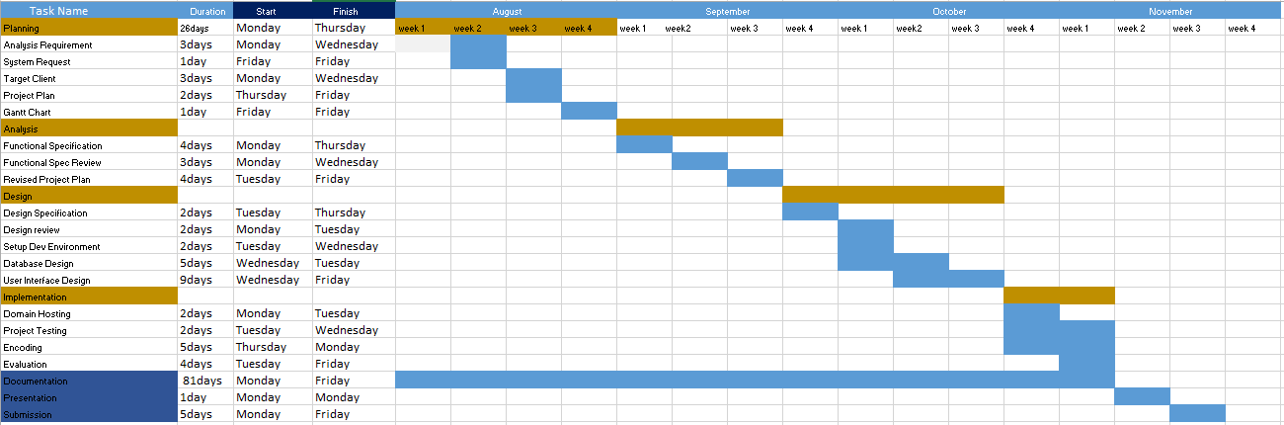**Gantt Chart**

Development Phase Duration Development Activity Duration